SIMATS ENGINEERING (SAVEETHA SCHOOL OF ENGINEERING)
Department of Computer Science and Engineering

ASSESSMENT TOOL 2 – CASE STUDY

Course Code: | CSA06 | Course Title: | Design and Analysis of Algorithms
CO Assessed: | CO3: Articulation (BL4, BL5) | Assessment: | Assessment Tool 2 – Case Study
Weightage: | 20% of CIA | Total Marks: | 100
CO3 Statement: | Design Divide and Conquer algorithms for Merge Sort, Quick Sort, Binary Search and Matrix Multiplication
Student Name: | N.Srinivas | Reg. No.: | 192372358
Section / Batch: | CSE(AI) | Date: | 08/08/2026

Instructions to Students
- Answer the following question. Total Marks: 100.
- Carefully analyze the given case study questions.
- Explain in detail with sample code if needed.
- Clearly identify all key issues, provide an in-depth analysis, and propose innovative, feasible solutions with strong justification.

Question Type | Focus Area | Questions
Case Study | Focus on Design Divide and Conquer algorithms: Merge Sort, Quick Sort, Binary Search and Matrix Multiplication | Q1

SECTION A – CASE STUDY

Code of Conduct
I N.Srinivas(192372358) (Name / Reg No) certify that this submission is my original work and that I have adhered to the guidelines specified for this assessment. I understand that any violation of academic integrity rules will result in disciplinary action.
Signature of the Student: _N.Srinivas

RUBRICS FOR CALCULATION

 |  | Case Study
Criteria | Weightage | Level 4 –  Exemplary | Level 3 –  Proficient | Level 2 –  Developing | Level 1 –  Beginning
Understanding of Case | 25% | Thorough understanding; clearly  identifies all key issues | Good understanding with most issues identified | Basic understanding;  some issues missed | Poor understanding;  problem not  identified correctly
Application of Concepts | 25% | Effectively applies relevant concepts to  analyze the case deeply | Applies appropriate  concepts with minor gaps | Limited application of concepts | Fails to apply relevant concepts
Analysis | 20% | In-depth analysis with strong  reasoning and insights | Good analysis with logical reasoning | Basic analysis with limited depth | Weak or no analysis; lacks reasoning
Solution Design | 20% | Innovative, feasible  solutions with strong justification | Logical solutions with adequate justification | Basic solutions with weak  justification | Incorrect or no solution provided
Clarity | 10% | Clear, wellstructured, and easy to understand | Organized and understandable presentation | Limited clarity and structure | Poor clarity; difficult to understand

Marks Evaluation:
Criteria | Wt. | Level 4 –  Exemplary | Level 3 –  Proficient | Level 2 –  Developing | Level 1 –  Beginning
Understanding of Case | 25%
Application of Concepts | 25%
Analysis | 20%
Solution Design | 20%
Clarity | 10%
Total Marks (100):

Faculty In-charge | Course Coordinator | Head of Department
Name: | Name: | Name:
Signature: _______________ | Signature: _______________ | Signature: _______________
Date: ___________________ | Date: ___________________ | Date: ___________________

Question :

Student Record Retrieval System (Binary Search) A university database stores student details in sorted order and requires quick search operations.
Analyze how Binary Search improves retrieval efficiency. Identify requirements such as sorted data and accuracy. Apply divide and conquer principles. Analyze time complexity. Design a solution and justify its effectiveness.

Solution :
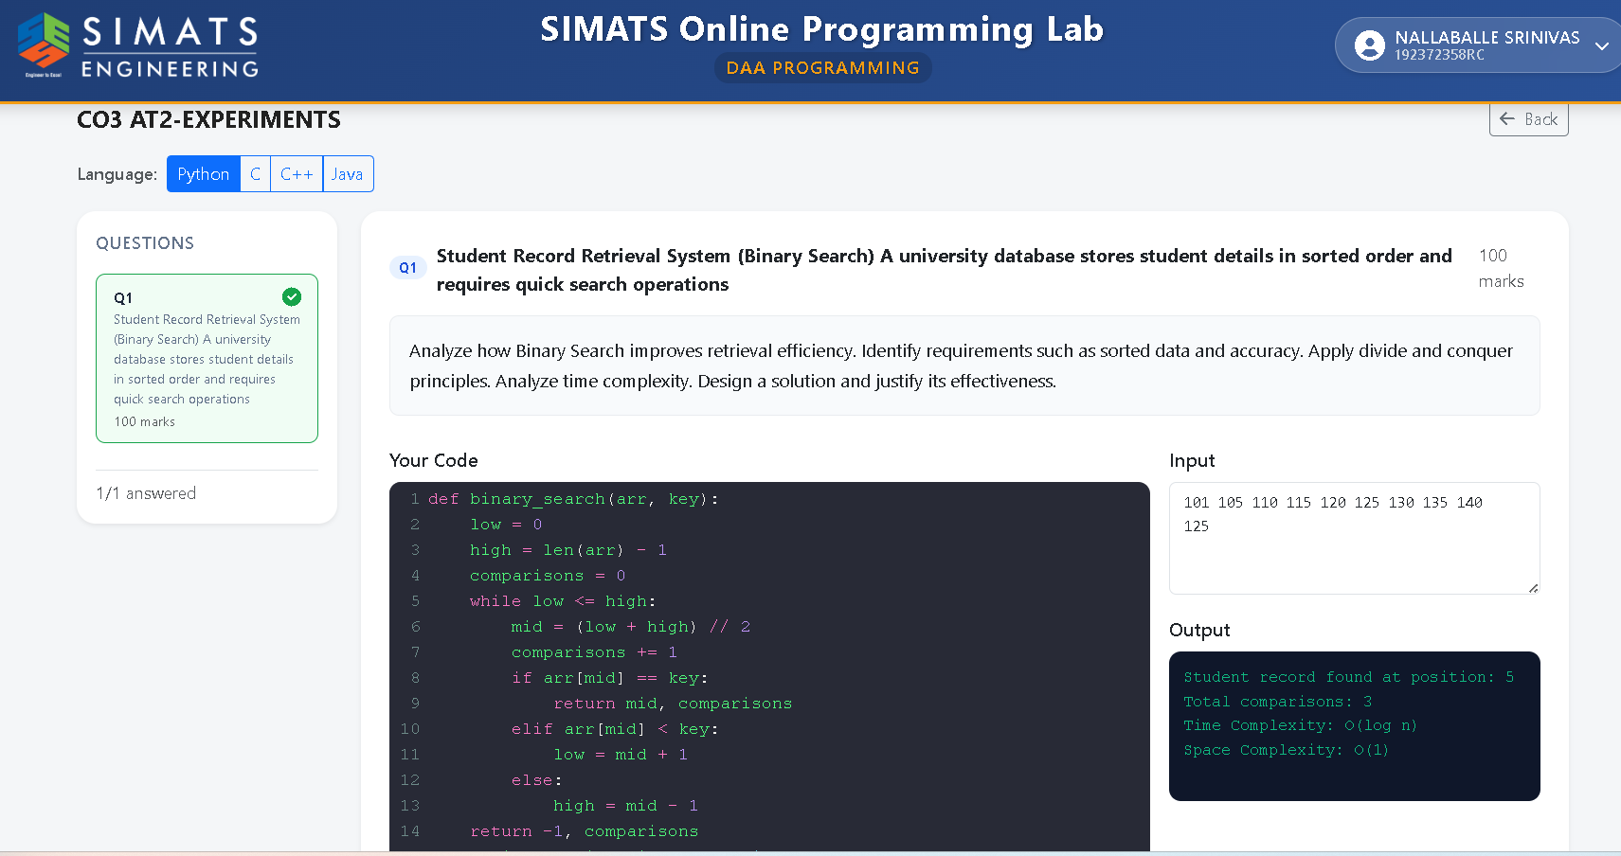
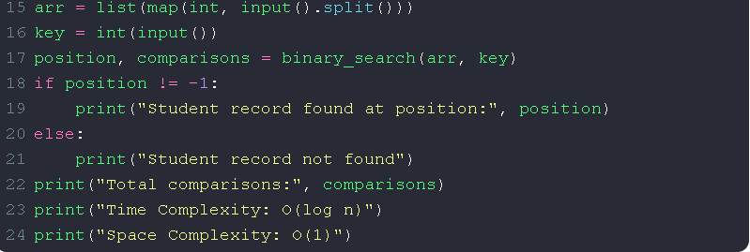
Student Record Retrieval System (Binary Search): A university database stores student details in sorted order and requires quick search operations. The system uses Binary Search to efficiently retrieve student records by repeatedly dividing the sorted data into two halves and eliminating the half that cannot contain the required record. This approach follows the divide-and-conquer principle and significantly reduces the number of comparisons. The main requirements are that the student records must be sorted based on a unique key such as student ID, and the search process must provide accurate results. Binary Search has a time complexity of O(log n), making it much faster than Linear Search with O(n) for large databases. Therefore, Binary Search is an effective solution for quick and efficient student record retrieval.

